

**Guide for Staff for Accessing and Understanding your Timetable**

Access to the online timetables is via MyBeckett.

* Go to [my.leedsbeckett.ac.uk/](https://my.leedsbeckett.ac.uk/) or use the Login Links on the staffsite.   
  A video and user guide on how to use CMISGo can be found on the Timetabling page [leedsbeckett.ac.uk/staffsite/services/registry-services/timetabling/](https://www.leedsbeckett.ac.uk/staffsite/services/registry-services/timetabling/)
* To login, enter your University username and password.
* On the MyBeckett homepage, look for the ‘Course’ card. Under this card, click ‘Your timetable’. Your individual timetable for the current week will be displayed.

* Any events that have changed since you logged in last will be highlighted with a red border as shown above. There is also a message at the bottom of the screen informing when the timetabled events were last updated from the main timetabling system.

PLEASE NOTE: **‘Distance Learning Students**do not have an on campus timetable, due to this there is no Timetable card on MyBeckett or any timetable information in the Leeds Beckett mobile App.

Teaching events display the module in the header.

Non-teaching events display the room in the header.

* Double clicking on the event will provide additional information.

Example of a timetabled event. Teaching events will include a campus map.

Example of a room booking

* The time periods available to view are Day, Week or Month. Change the view by selecting ‘**Timetables**’ (top right).

* The navigate icons (top left) let you navigate to the previous or next day, week or month (depending on your current timetable view). The **Go to date** icon lets you navigate by selecting a date from the calendar.

**Event Information**

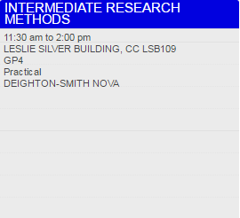

**Room Code**

The room code states the campus, building, then room number, and begins with either HC or CC. HC = Headingley Campus; CC = City Campus.  
After the campus and building codes, the room number is indicated.  
Numbers prefixed by ‘G’ are on the ground floor (e.g. G15)  
Numbers beginning with ‘1’ are on the first floor (e.g. 105)  
Numbers beginning with ‘2’ are on the second floor (e.g. 227)

For example:

**Campus Building Room number**

**CC LSB107** = CC (City Campus) LSB (Leslie Silver Building) 107 (1st floor)

**HC CAEG03** = HC (Headingley Campus) CAE (Caedmon) G03 (ground floor)

**Type of Event**

Here is a guide to each kind of event that could appear on your timetable:

Assessment: Any method of assessment other than an examination - such as a performance or practical session - which tests your knowledge / proficiency in a subject or skill.

Drop in: an optional session to support students in specific areas of study. Students can attend all or part of the session.

Examination: A formal test of your knowledge / proficiency in a subject or skill.

IT Lab: A session delivered in a computer laboratory.

Lecture: A delivery of information from a lecturer to a large group of students, often from a range of courses and modules.

Lecture / Seminar: A delivery of information from lecturer to students. This may involve lecture-style delivery followed by group work.

Offsite: An event that is delivered away from the university campus. (This will still appear on your timetable.)

Online: A session delivered online.

Practical: A specialist, course-specific practical session run in School specialist facilities.

IT Practical: A course-specific IT session, run in an IT laboratory.

Presentations: A session where you and/or other students present your work.

Project Work: A session to work on a set project, sometimes as part of a group.

Resit Exam: An examination that you have already attempted, that you are going to re-attempt. Resit examinations normally occur at the end of a semester.

Science Practical: A course specific practical session run in a specialist science lab

Seminar: An interactive session between lecturer and students, often involving group work. Seminars are smaller than a lecture and part of a specific course. Seminars give the opportunity for questions, discussion and group work.

Sports Practical: A session focussing on a specific sport/s, run in a specialist sports facility

Support Session: An additional session to support your studies.

Tutorial: A meeting involving you and your personal tutor - normally 1:1 or a small group - which focuses on your course or academic issues, or on wider concerns.

Workshop: A group session involving intensive discussion and activity on a particular subject or project.

Work placement: Work to be undertaken outside of your course, in a workplace environment.

**Help function**

* Select the question mark symbol  to access this function and select  to view the Help function in a new browser.
* Provides assistance in all areas of CMISGo

**Additional Timetable Views**

* The timetable list feature lets you display other types of timetables either instead of or at the same time as your own or other timetables. These include the following:

* Select the ‘**Toggle timetable list’** icon , then ‘**Add**’ (bottom of the screen).

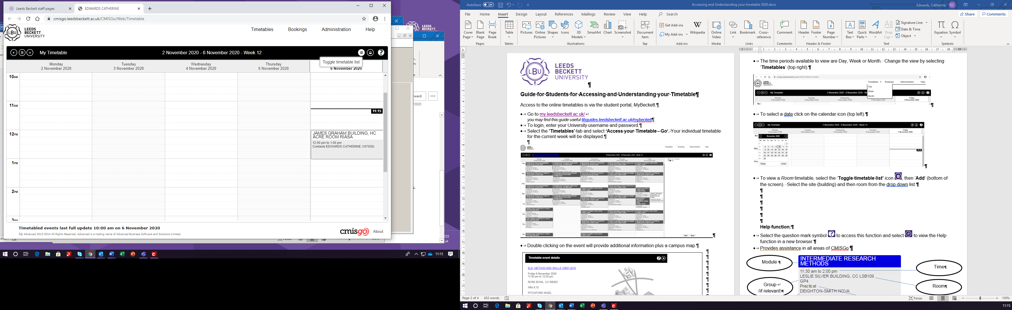



* For example, the Room tab provides drop down lists that let you select a room, when you have selected a room clicking the OK button will add that timetable to your timetable list.

**Managing the Timetable List**

* A timetable can be removed from the list by clicking the delete icon associated with it, (found at the end of the line).
* Timetables are also automatically assigned a colour which is used to indicate why an item is being shown in the main time timetable display, this is shown in the example below.
* The timetable list is preserved during your browser session but it is not automatically saved between browser sessions. If you want to preserve it to use again in a future browser session use the Save button. The list of timetables together with each timetable's checked state is saved and is automatically used again in any future browser session.

**Check Room Use**

* To view the bookings in a building select Administration/Room use.

* Select either a building or a zone and a date.

* Yellow indicates the room is available to book and the red indicates the room is booked.
* To view details of the booking click on the relevant red area.

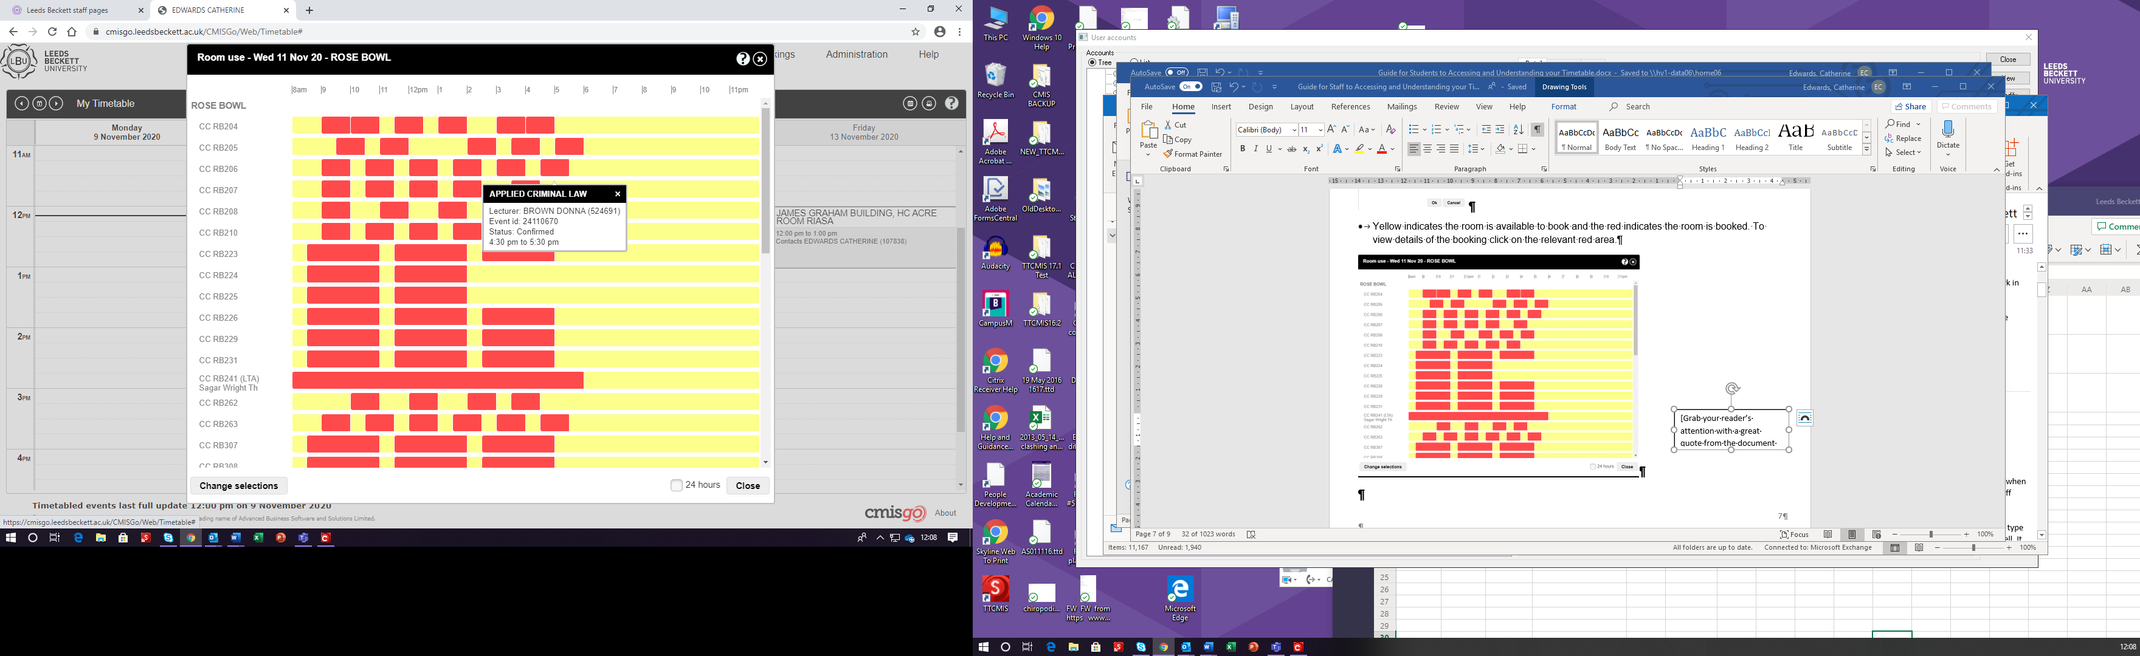

* To select a different building, zone or date click **Change selections**.

**Print Timetable**

* To print a timetable, select the Print icon (top right).

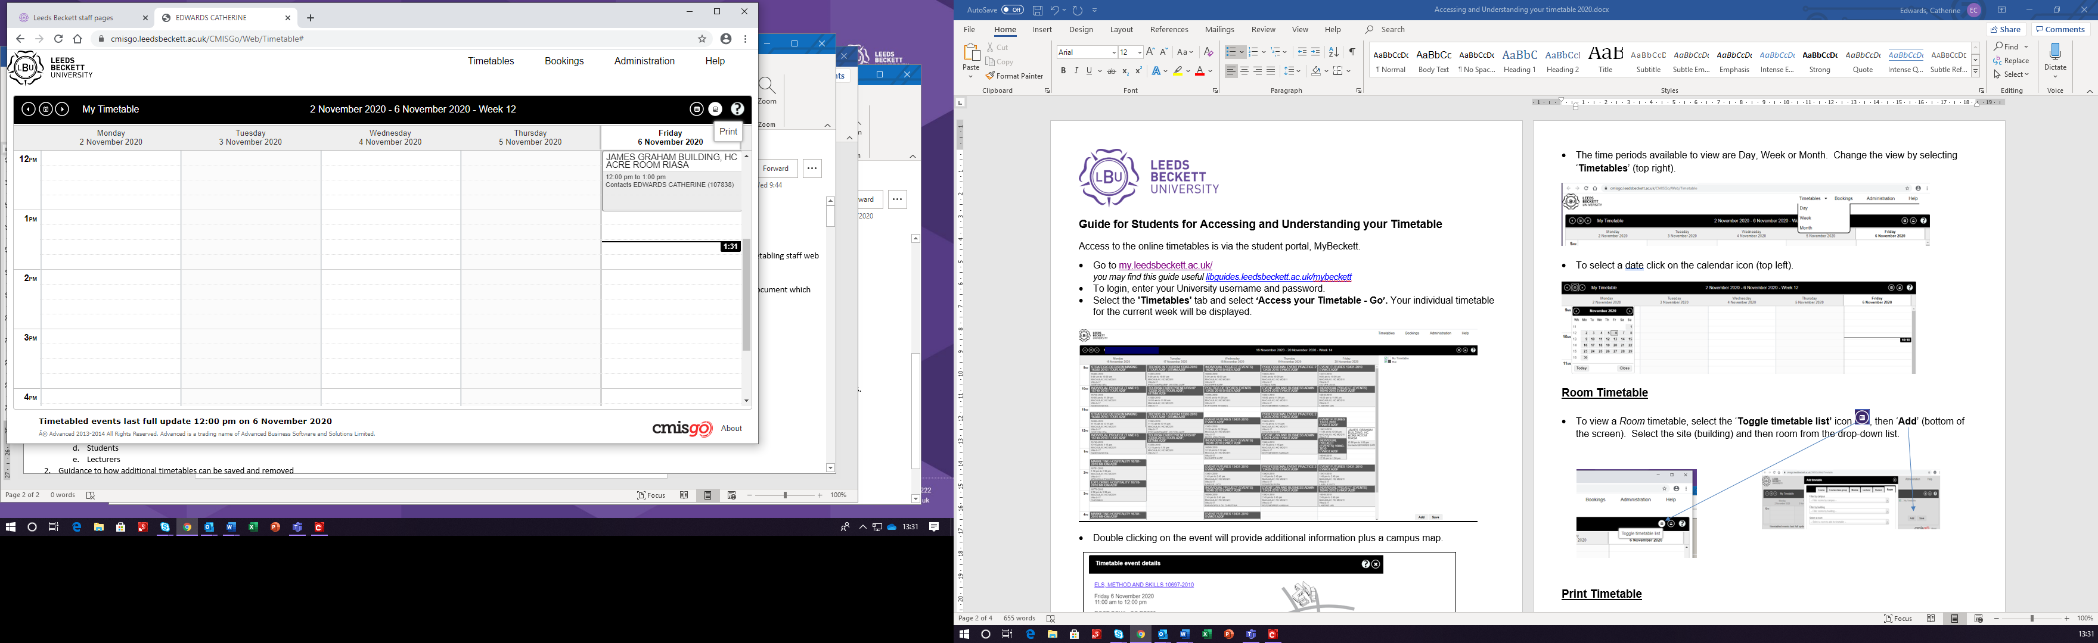

**Campus Maps**

You can access and download our campus maps PDF at

<https://www.leedsbeckett.ac.uk/-/media/files/we-are-beckett/mu_campus_maps_sep21.pdf>

**Term dates**

See [www.leedsbeckett.ac.uk/our-university/term-dates/](http://www.leedsbeckett.ac.uk/our-university/term-dates/) for term dates.