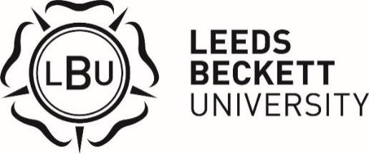

Bright Futures Scholarship
2023/2024

Overview

The Bright Futures Scholarship is supported by alumni and friends of Leeds Beckett University to ensure that the opportunity to experience and benefit from an education at Leeds Beckett University is open to all, regardless of background. The scholarship is a cash award of £1,500 for first year students, paid in instalments over three years. There are a limited number of scholarships available to award each academic year. Applicants will need to have an annual household income of £27,500 or less and be the first in their family to attend university. Students who are eligible to apply, according to information on their student record, will be contacted via their student email address and applications will be online through MyHub.

Eligibility Criteria

The scholarship is open to applications from candidates who meet the criteria below:

- Be the first in their immediate family to attend university.
- Have a household income of £27,500 or less.
- Be in their first year of study of their first undergraduate degree.

Application Process

Candidates who are eligible according to information on their student record will be contacted through their student email and notifications on MyHub. If you believe you are eligible but have not been contacted, please contact the Bursary & Scholarship Officer.

Applications will open in October 2023. If your application is successful you will be invited to an interview. Interview dates for this scholarship will be in November/December. Specific dates and times will be confirmed when applicants are successfully shortlisted for interview. Successful scholars will be notified in December.

Payment

The first instalment of scholarship payment will be awarded in January 2024 and paid directly to a nominated bank account. The payment schedule can be amended for accelerated degrees or sandwich degrees.

General

Full terms and conditions of the scholarship will be provided to successful scholars before formally accepting the scholarship. The payment schedule can be amended for accelerated degrees or sandwich degrees.

The university retains the right to vary the terms and conditions of the application process as it deems appropriate.

If you have any queries please contact the Bursary & Scholarship Officer via email on bursaryandscholarship@leedsbeckett.ac.uk, or telephone 0113 812 5859.

